HIGH LEVEL LANGUAGE EXTENSION WITH CURSORS

Exp. No**:** 18

Date:

Aim:

To implement Cursors using program in MySQL.

Declare , Close and Deallocate a cursor:

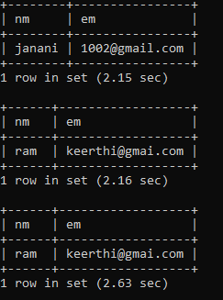

RESULT: Thus the Cursor program using MySQL is executed successfully.